JavaScript Assignment #2

**Part 1: What’s Your GPA**

[Paste your part 1 Code below]

**<!DOCTYPE html>**

**<html lang="en">**

**<head>**

**<meta charset="utf-8">**

**<meta name="viewport" content="width=device-width, initial-scale=1.0">**

**<title>Patrick Pelayo A2P1</title>**

**</head>**

**<body>**

**<h1>Patrick Pelayo A2P1</h1>**

**<script>**

**//Functions**

**//This function acts as a main(note it wraps a setTimeout, as I wanted to ensure the dom loaded first)**

**(function() {**

**setTimeout(function() {**

**//variables**

**var fName; //First name of user**

**//get the user first name**

**fName = get_f_name();**

**//Now get the GPA and tell user the grade**

**getProcG(fName);**

**}, 1000);**

**})()**

**//This function gets the first name and returns it**

**function get_f_name() {**

**//variables**

**var fName, //User First Name**

**regEx = /[^A-Z]/i, //Ensure input only works for A-Z regardless of case NOTE: attempted [^A-z] but it allowed ` and //^ as input**

**regEx2 = /\s/, //to check for whitespace**

**prmt = "Please enter your first name.", //The name prompt**

**prmtE = "Invalid input,\nPlease enter your first name.", //String for invalid input**

**flag; //Flag for the do while loop**

**//input validate letters only/ don't allow last name**

**do {**

**//set flag false**

**flag = false;**

**//prompt for the user first name**

**fName = prompt(prmt);**

**//trim the string of white space if present**

**fName = fName.trim();**

**//If user entered more than one name, take only first name**

**if (regEx2.test(fName)) {**

**alert("You entered a last name as well, this was removed.");**

**fName = fName.split(" ", 1);**

**}**

**//now check for decimals which are not valid in a**

**//name, if present set flag true, and change prompt**

**if (regEx.test(fName)) {**

**flag = true;**

**prmt = prmtE;**

**}**

**//check for no input**

**if (fName === "") {**

**flag = true;**

**prmt = prmtE;**

**}**

**} while (flag === true)**

**//return the first name**

**return fName;**

**}**

**//this function displays the user's first name, then gets the current GPA, then outputs XXXX, your GPA of X.XX results in a // X grade.**

**function getProcG(fName) {**

**//Structs,objects**

**var Grades = {**

**A: 4.0,**

**B: 3.0,**

**C: 2.0,**

**D: 1.0,**

**F: 0.0**

**};**

**//variables**

**var gpa, //User entered GPA**

**prmpt = "Please enter your GPA, " + fName, //Prompts "Please enter your GPA, XXXX**

**gpaE = "That inut is not valid, enter only a GPA from 0.0-4.0\n Please enter your GPA, " + fName;**

**//prompt user**

**gpa = prompt(prmpt);**

**//input validate, accept only 0-4 GPA**

**while (!(gpa >= 0.0 && gpa <= Grades.A))**

**gpa = prompt(gpaE);**

**//convert to floating point(needed for toFixed())**

**gpa = parseFloat(gpa);**

**//Build the header(document.write clears the dom body)**

**document.write("<h1>Patrick Pelayo A2P1</h1>");**

**//output the name,GPA,Grade message**

**if (gpa == Grades.A)**

**document.write("<p>" + fName + ", your GPA of " + gpa.toFixed(2) + " results in an A grade.</p>");**

**else {**

**if (gpa < Grades.A && gpa >= Grades.B)**

**document.write("<p>" + fName + ", your GPA of " + gpa.toFixed(2) + " results in a B grade.</p>");**

**else {**

**if (gpa < Grades.B && gpa >= Grades.C)**

**document.write("<p>" + fName + ", your GPA of " + gpa.toFixed(2) + " results in a C grade.</p>");**

**else {**

**if (gpa < Grades.C && gpa >= Grades.D)**

**document.write("<p>" + fName + ", your GPA of " + gpa.toFixed(2) + " results in a D grade.</p>");**

**else {**

**if (gpa < Grades.D)**

**document.write("<p>" + fName + ", your GPA of " + gpa.toFixed(2) + " results in a F grade.</p>");**

**}**

**}**

**}**

**}**

**}**

**</script>**

**</body>**

**</html>**

**Part 2: Gimme Some Products**

[Paste your part 2 screen shot below]

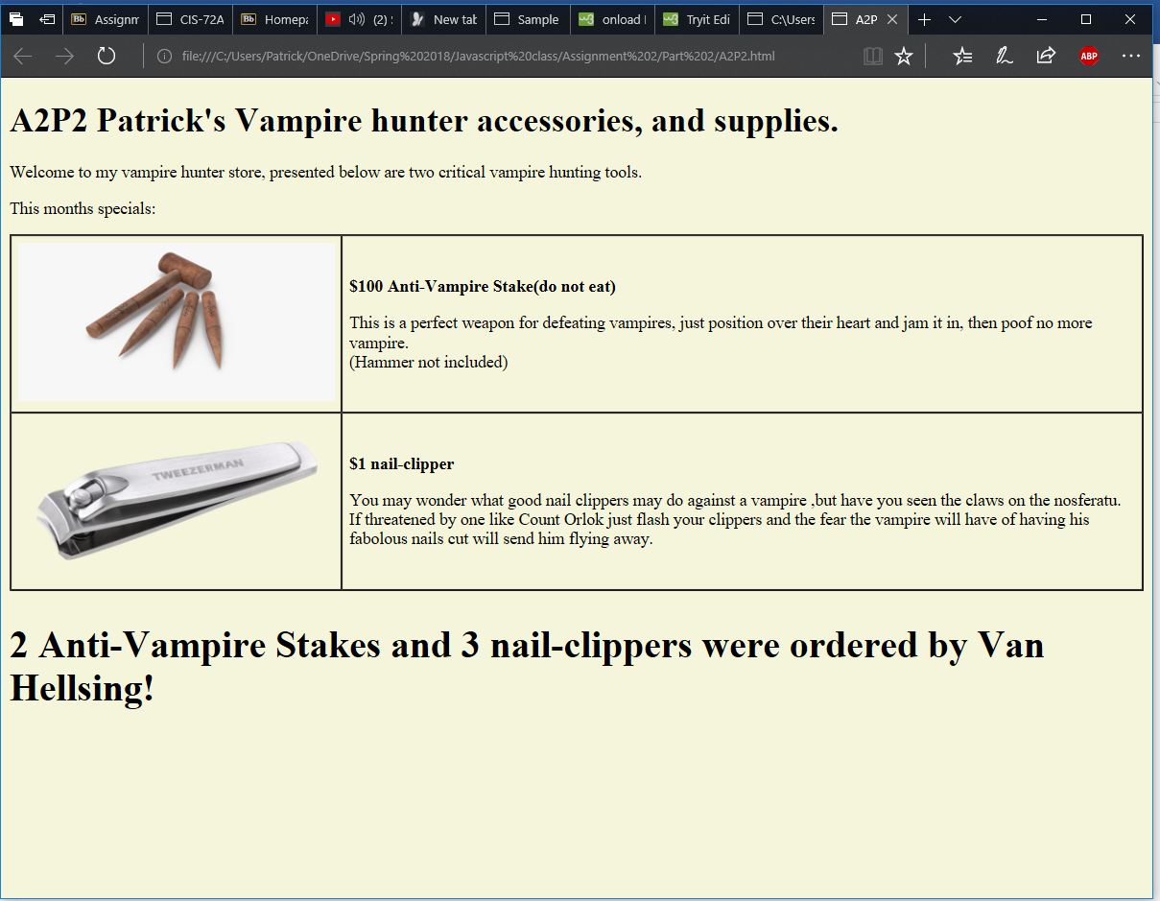

[Paste your part 2 Code below]

**<!doctype html>**

**<html>**

**<head>**

**<meta charset="utf-8">**

**<title>A2P2 by YOUR NAME HERE</title>**

**</head>**

**<body>**

**<h1>A2P2 STORE NAME GOES HERE</h1>**

**<p>STORE INTRODUCTION GOES HERE</p>**

**<p>This months specials:</p>**

**<table border="1" cellspacing="0" cellpadding="6" summary="Table of product images and prices and descriptions">**

**<tbody>**

**<tr>**

**<td>PRODUCT IMAGE #1 GOES HERE</td>**

**<td>**

**<p style="font-weight: bold">PRICE AND PRODUCT NAME #1 GOES HERE </p>**

**<p>PRODUCT #1 DESCRIPTION GOES HERE </p>**

**</td>**

**</tr>**

**<tr>**

**<td>PRODUCT IMAGE #2 GOES HERE</td>**

**<td>**

**<p style="font-weight: bold">PRICE AND PRODUCT NAME #2 GOES HERE </p>**

**<p>PRODUCT #2 DESCRIPTION GOES HERE </p>**

**</td>**

**</tr>**

**</tbody>**

**</table>**

**<script>**

**//Functions**

**//This acts as a main for web page**

**(function() {**

**//structs,significant objects**

**var Customer = {**

**name: 0, //Customer's name**

**item: [] //# of items ordered**

**};**

**//variables**

**var products = ["Anti-Vampire Stake", "nail-clipper"],**

**outPut,**

**temp;**

**//update the page**

**updateP(Customer);**

**//wait a second for page to load then process the requests**

**setTimeout(function() {**

**//Prompt user for their name**

**getN(Customer);**

**//Order purchase**

**buy(Customer, products);**

**//Output string**

**outPut = "<h2>" + Customer.item[0] + " " + products[0] + "s " + " and " + Customer.item[1] + " " + products[1] + "s were ordered by " + Customer.name + "!";**

**/* Forced to create a new element as write will overwrite the current page of its html */**

**temp = document.createElement("h2");**

**temp.innerHTML = outPut;**

**document.getElementsByTagName("body")[0].appendChild(temp);**

**}, 1000);**

**})()**

**//This function will change the HTML to the store one<updates page>. Where is the fun changing HTML directly?**

**function updateP() {**

**//variables**

**var strN = "A2P2 Patrick's Vampire hunter accessories, and supplies.",**

**strIn = "Welcome to my vampire hunter store, presented below are two critical vampire hunting tools.",**

**prd1D = "This is a perfect weapon for defeating vampires, just position over their heart and jam it in, then poof no more vampire. <br> (Hammer not included)",**

**prd1P = "$100 Anti-Vampire Stake(do not eat)",**

**prd2D = "You may wonder what good nail clippers may do against a vampire ,but have you seen the claws on the nosferatu. If threatened by one like Count Orlok just flash your clippers and the fear the vampire will have of having his fabolous nails cut will send him flying away.",**

**prd2P = "$1 nail-clipper",**

**title = "A2P2 by Patrick Pelayo",**

**width = "300",**

**height = "150",**

**temp;**

**//set background beige**

**document.getElementsByTagName("body")[0].style.background = "beige";**

**//change all the html thru javascript**

**document.getElementsByTagName("h1")[0].innerHTML = strN;**

**document.getElementsByTagName("p")[0].innerHTML = strIn;**

**document.getElementsByTagName("p")[2].innerHTML = prd1P;**

**document.getElementsByTagName("p")[3].innerHTML = prd1D;**

**document.getElementsByTagName("p")[4].innerHTML = prd2P;**

**document.getElementsByTagName("p")[5].innerHTML = prd2D;**

**document.getElementsByTagName("title")[0].innerHTML = title;**

**//do the images**

**temp = document.createElement("IMG");**

**temp.src = "stake.jpg";**

**temp.width = width;**

**temp.height = height;**

**document.getElementsByTagName("td")[0].innerHTML = "";**

**document.getElementsByTagName("td")[0].appendChild(temp);**

**//second image**

**temp = document.createElement("IMG");**

**temp.src = "nailClipper.png";**

**temp.width = width;**

**temp.height = height;**

**document.getElementsByTagName("td")[2].innerHTML = "";**

**document.getElementsByTagName("td")[2].appendChild(temp);**

**}**

**//this function gets a customer object, and gets the user name**

**function getN(Customer) {**

**//variables**

**var regEx1 = /[^A-Z ]/i, //Ensure only letters inputed for a name**

**prmptMsg = "Welcome to Patrick's vampire hunter accessories, and supplies. What is your name?",**

**prmptEr = "Name's cannot contain numbers or symbols, please re-enter your name.",**

**prmptEr2 = "You must enter a name",**

**aSpace = " ", //Simply a space for validation**

**defaultN = "Van Hellsing"; //default name**

**//prompt for the name of the user,perform input validation**

**Customer.name = prompt(prmptMsg, defaultN);**

**//trim any white space**

**Customer.name.trim();**

**//check for invalid input**

**while (regEx1.test(Customer.name) || (Customer.name[0] === aSpace)) {**

**if (Customer.name[0] === aSpace)**

**Customer.name = prompt(prmptEr2, defaultN);**

**else**

**Customer.name = prompt(prmptEr, defaultN);**

**//trim any white space**

**Customer.name.trim();**

**}**

**}**

**//This function gets the # of desired items for each item type**

**function buy(Customer, prod) {**

**//variables**

**var error = "That is not valid input, you must enter a number.\n";**

**//get the # of orders for the customer**

**for (var i = 0; i < prod.length; i++) {**

**//prompt**

**Customer.item[i] = prompt(Customer.name + " how many " + prod[i] + "s would you like to purchase?");**

**//trim the string**

**Customer.item[i] = Customer.item[i].trim();**

**//input validate**

**while (Customer.item[i] < 0 || !(Customer.item[i] >= 0) || (Customer.item[i]).length === 0) {**

**Customer.item[i] = prompt(error + Customer.name + " how many " + prod[i] + "s would you like to purchase?");**

**//trim the string**

**Customer.item[i] = Customer.item[i].trim();**

**}**

**}**

**}**

**</script>**

**</body>**

**</html>**

**Part 3: Receipt This!**

[Page Your part 3 Screenshot below]

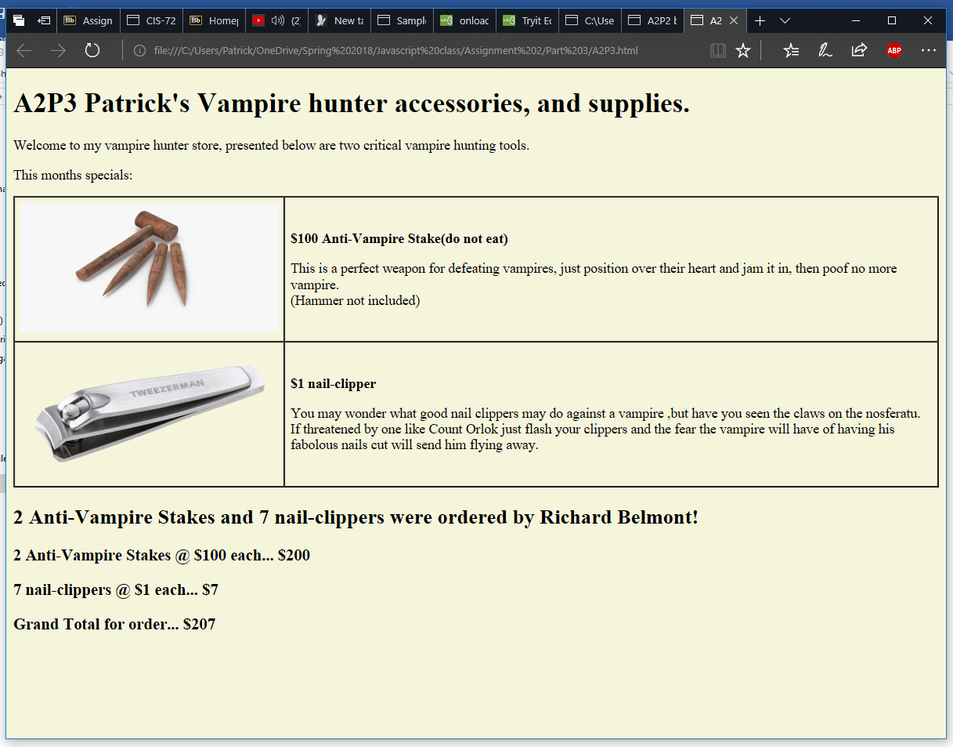

[Paste your part 3 Code Below your screen shot]

**<!doctype html>**

**<html>**

**<head>**

**<meta charset="utf-8">**

**<title>A2P3 by YOUR NAME HERE</title>**

**</head>**

**<body>**

**<h1>A2P3 STORE NAME GOES HERE</h1>**

**<p>STORE INTRODUCTION GOES HERE</p>**

**<p>This months specials:</p>**

**<table border="1" cellspacing="0" cellpadding="6" summary="Table of product images and prices and descriptions">**

**<tbody>**

**<tr>**

**<td>PRODUCT IMAGE #1 GOES HERE</td>**

**<td>**

**<p style="font-weight: bold">PRICE AND PRODUCT NAME #1 GOES HERE </p>**

**<p>PRODUCT #1 DESCRIPTION GOES HERE </p>**

**</td>**

**</tr>**

**<tr>**

**<td>PRODUCT IMAGE #2 GOES HERE</td>**

**<td>**

**<p style="font-weight: bold">PRICE AND PRODUCT NAME #2 GOES HERE </p>**

**<p>PRODUCT #2 DESCRIPTION GOES HERE </p>**

**</td>**

**</tr>**

**</tbody>**

**</table>**

**<script>**

**//Functions**

**//This acts as a main for web page**

**(function() {**

**//structs,significant objects**

**var Customer = {**

**name: 0, //Customer's name**

**item: [], //# of items ordered**

**itemTtl: [], //Cost per item, || array with Item []**

**subTtl: 0 //Customer subtotal spent**

**};**

**//variables**

**var products = ["Anti-Vampire Stake", "nail-clipper"],**

**prodPrice = [100, 1], //|| array for the products**

**outPut,**

**temp;**

**//update the page**

**updateP(Customer);**

**//wait a second for page to load then process the requests**

**setTimeout(function() {**

**//Prompt user for their name**

**getN(Customer);**

**//Order purchase**

**buy(Customer, products);**

**//Process the costs**

**calcTtl(Customer, prodPrice);**

**//The output follows this point//**

**//Output string**

**outPut = Customer.item[0] + " " + products[0] + "s " + " and " + Customer.item[1] + " " + products[1] + "s were ordered by " + Customer.name + "!";**

**/* Forced to create a new element as write will overwrite the current page of its html */**

**//Output the h2**

**temp = document.createElement("h2");**

**temp.innerHTML = outPut;**

**document.getElementsByTagName("body")[0].appendChild(temp);**

**//Output string**

**outPut = Customer.item[0] + " " + products[0] + "s @ $" + prodPrice[0] + " each... $" + Customer.itemTtl[0];**

**//output the three totals as <h3> appended**

**temp = document.createElement("h3");**

**temp.innerHTML = outPut;**

**document.getElementsByTagName("body")[0].appendChild(temp);**

**//Output string**

**outPut = Customer.item[1] + " " + products[1] + "s @ $" + prodPrice[1] + " each... $" + Customer.itemTtl[1];**

**//2nd h3**

**temp = document.createElement("h3");**

**temp.innerHTML = outPut;**

**document.getElementsByTagName("body")[0].appendChild(temp);**

**//Output string**

**outPut = "Grand Total for order... $" + Customer.subTtl;**

**//3rd h3**

**temp = document.createElement("h3");**

**temp.innerHTML = outPut;**

**document.getElementsByTagName("body")[0].appendChild(temp);**

**}, 1000);**

**})()**

**//This function processes the cost of the item and stores it into the customer object**

**function calcTtl(Customer, prodPrice) {**

**//variables**

**//calculate the ttls of each item**

**for (var i = 0; i < prodPrice.length; i++) {**

**Customer.itemTtl[i] = prodPrice[i] * Customer.item[i];**

**Customer.subTtl += Customer.itemTtl[i];**

**}**

**}**

**//This function will change the HTML to the store one<updates page>. Where is the fun changing HTML directly?**

**function updateP() {**

**//variables**

**var strN = "A2P3 Patrick's Vampire hunter accessories, and supplies.",**

**strIn = "Welcome to my vampire hunter store, presented below are two critical vampire hunting tools.",**

**prd1D = "This is a perfect weapon for defeating vampires, just position over their heart and jam it in, then poof no more vampire. <br> (Hammer not included)",**

**prd1P = "$100 Anti-Vampire Stake(do not eat)",**

**prd2D = "You may wonder what good nail clippers may do against a vampire ,but have you seen the claws on the nosferatu. If threatened by one like Count Orlok just flash your clippers and the fear the vampire will have of having his fabolous nails cut will send him flying away.",**

**prd2P = "$1 nail-clipper",**

**title = "A2P3 by Patrick Pelayo",**

**width = "300",**

**height = "150",**

**temp;**

**//set background beige**

**document.getElementsByTagName("body")[0].style.background = "beige";**

**//change all the html thru javascript**

**document.getElementsByTagName("h1")[0].innerHTML = strN;**

**document.getElementsByTagName("p")[0].innerHTML = strIn;**

**document.getElementsByTagName("p")[2].innerHTML = prd1P;**

**document.getElementsByTagName("p")[3].innerHTML = prd1D;**

**document.getElementsByTagName("p")[4].innerHTML = prd2P;**

**document.getElementsByTagName("p")[5].innerHTML = prd2D;**

**document.getElementsByTagName("title")[0].innerHTML = title;**

**//do the images**

**temp = document.createElement("IMG");**

**temp.src = "stake.jpg";**

**temp.width = width;**

**temp.height = height;**

**document.getElementsByTagName("td")[0].innerHTML = "";**

**document.getElementsByTagName("td")[0].appendChild(temp);**

**//second image**

**temp = document.createElement("IMG");**

**temp.src = "nailClipper.png";**

**temp.width = width;**

**temp.height = height;**

**document.getElementsByTagName("td")[2].innerHTML = "";**

**document.getElementsByTagName("td")[2].appendChild(temp);**

**}**

**//this function gets a customer object, and gets the user name**

**function getN(Customer) {**

**//variables**

**var regEx1 = /[^A-Z ]/i, //Ensure only letters inputed for a name**

**prmptMsg = "Welcome to Patrick's vampire hunter accessories, and supplies. What is your name?",**

**prmptEr = "Name's cannot contain numbers or symbols, please re-enter your name.",**

**prmptEr2 = "You must enter a name",**

**aSpace = " ", //Simply a space for validation**

**defaultN = "Van Hellsing"; //default name**

**//prompt for the name of the user,perform input validation**

**Customer.name = prompt(prmptMsg, defaultN);**

**//trim any white space**

**Customer.name.trim();**

**//check for invalid input**

**while (regEx1.test(Customer.name) || (Customer.name[0] === aSpace)) {**

**if (Customer.name[0] === aSpace)**

**Customer.name = prompt(prmptEr2, defaultN);**

**else**

**Customer.name = prompt(prmptEr, defaultN);**

**//trim any white space**

**Customer.name.trim();**

**}**

**}**

**//This function gets the # of desired items for each item type**

**function buy(Customer, prod) {**

**//variables**

**var error = "That is not valid input, you must enter a number.\n";**

**//get the # of orders for the customer**

**for (var i = 0; i < prod.length; i++) {**

**//prompt**

**Customer.item[i] = prompt(Customer.name + " how many " + prod[i] + "s would you like to purchase?");**

**//trim the string**

**Customer.item[i] = Customer.item[i].trim();**

**//input validate**

**while (Customer.item[i] < 0 || !(Customer.item[i] >= 0) || (Customer.item[i]).length === 0) {**

**Customer.item[i] = prompt(error + Customer.name + " how many " + prod[i] + "s would you like to purchase?");**

**//trim the string**

**Customer.item[i] = Customer.item[i].trim();**

**}**

**}**

**}**

**</script>**

**</body>**

**</html>**

**Part 4: If it Don’t Make Dollar$, it Don’t Make ¢ents!**

[Page Your part 4 Screenshot below]

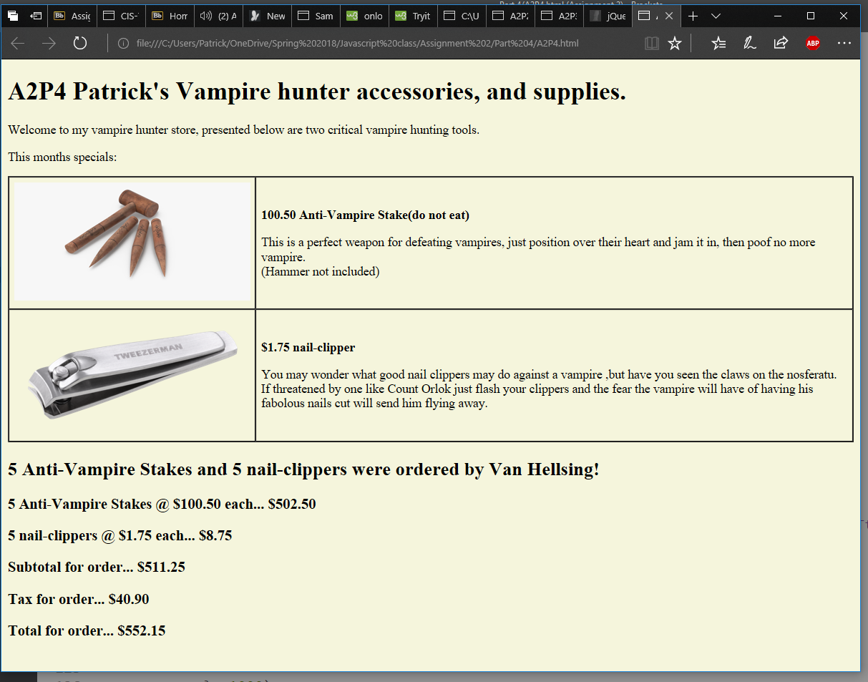

[Paste your part 4 Code Below your screen shot]

**<!doctype html>**

**<html>**

**<head>**

**<meta charset="utf-8">**

**<title>A2P4 by YOUR NAME HERE</title>**

**</head>**

**<body>**

**<h1>A2P4 STORE NAME GOES HERE</h1>**

**<p>STORE INTRODUCTION GOES HERE</p>**

**<p>This months specials:</p>**

**<table border="1" cellspacing="0" cellpadding="6" summary="Table of product images and prices and descriptions">**

**<tbody>**

**<tr>**

**<td>PRODUCT IMAGE #1 GOES HERE</td>**

**<td>**

**<p style="font-weight: bold">PRICE AND PRODUCT NAME #1 GOES HERE </p>**

**<p>PRODUCT #1 DESCRIPTION GOES HERE </p>**

**</td>**

**</tr>**

**<tr>**

**<td>PRODUCT IMAGE #2 GOES HERE</td>**

**<td>**

**<p style="font-weight: bold">PRICE AND PRODUCT NAME #2 GOES HERE </p>**

**<p>PRODUCT #2 DESCRIPTION GOES HERE </p>**

**</td>**

**</tr>**

**</tbody>**

**</table>**

**<script>**

**//Functions**

**//This acts as a main for web page**

**(function() {**

**//structs,significant objects**

**var Customer = {**

**name: 0, //Customer's name**

**item: [], //# of items ordered**

**itemTtl: [], //Cost per item, || array with Item []**

**subTtl: 0 //Customer subtotal spent**

**};**

**//variables**

**var products = ["Anti-Vampire Stake", "nail-clipper"],**

**prodPrice = [100.50, 1.75], //|| array for the products**

**outPut,**

**temp;**

**//update the page**

**updateP(Customer);**

**//wait a second for page to load then process the requests**

**setTimeout(function() {**

**//Prompt user for their name**

**getN(Customer);**

**//Order purchase**

**buy(Customer, products);**

**//Process the costs**

**calcTtl(Customer, prodPrice);**

**//The output follows this point//**

**//Output string**

**outPut = Customer.item[0] + " " + products[0] + "s " + " and " + Customer.item[1] + " " + products[1] + "s were ordered by " + Customer.name + "!";**

**/* Forced to create a new element as write will overwrite the current page of its html */**

**//Output the h2**

**temp = document.createElement("h2");**

**temp.innerHTML = outPut;**

**document.getElementsByTagName("body")[0].appendChild(temp);**

**//Output string**

**outPut = Customer.item[0] + " " + products[0] + "s @ $" + prodPrice[0].toFixed(2) + " each... $" + Customer.itemTtl[0].toFixed(2);**

**//output the three totals as <h3> appended**

**temp = document.createElement("h3");**

**temp.innerHTML = outPut;**

**document.getElementsByTagName("body")[0].appendChild(temp);**

**//Output string**

**outPut = Customer.item[1] + " " + products[1] + "s @ $" + prodPrice[1].toFixed(2) + " each... $" + Customer.itemTtl[1].toFixed(2);**

**//2nd h3**

**temp = document.createElement("h3");**

**temp.innerHTML = outPut;**

**document.getElementsByTagName("body")[0].appendChild(temp);**

**//Output string**

**outPut = "Subtotal for order... $" + Customer.subTtl.toFixed(2);**

**//3rd h3**

**temp = document.createElement("h3");**

**temp.innerHTML = outPut;**

**document.getElementsByTagName("body")[0].appendChild(temp);**

**//Display tax h3**

**//Output string**

**outPut = "Tax for order... $" + (Customer.subTtl * 0.08).toFixed(2);**

**//3rd h3**

**temp = document.createElement("h3");**

**temp.innerHTML = outPut;**

**document.getElementsByTagName("body")[0].appendChild(temp);**

**//Grand total with tax**

**//Output string**

**outPut = "Total for order... $" + (Customer.subTtl * 0.08 + Customer.subTtl).toFixed(2);**

**//3rd h3**

**temp = document.createElement("h3");**

**temp.innerHTML = outPut;**

**document.getElementsByTagName("body")[0].appendChild(temp);**

**}, 1000);**

**})()**

**//This function processes the cost of the item and stores it into the customer object**

**function calcTtl(Customer, prodPrice) {**

**//variables**

**//calculate the ttls of each item**

**for (var i = 0; i < prodPrice.length; i++) {**

**Customer.itemTtl[i] = prodPrice[i] * Customer.item[i];**

**Customer.subTtl += Customer.itemTtl[i];**

**}**

**}**

**//This function will change the HTML to the store one<updates page>. Where is the fun changing HTML directly?**

**function updateP() {**

**//variables**

**var strN = "A2P4 Patrick's Vampire hunter accessories, and supplies.",**

**strIn = "Welcome to my vampire hunter store, presented below are two critical vampire hunting tools.",**

**prd1D = "This is a perfect weapon for defeating vampires, just position over their heart and jam it in, then poof no more vampire. <br> (Hammer not included)",**

**prd1P = "100.50 Anti-Vampire Stake(do not eat)",**

**prd2D = "You may wonder what good nail clippers may do against a vampire ,but have you seen the claws on the nosferatu. If threatened by one like Count Orlok just flash your clippers and the fear the vampire will have of having his fabolous nails cut will send him flying away.",**

**prd2P = "$1.75 nail-clipper",**

**title = "A2P4 by Patrick Pelayo",**

**width = "300",**

**height = "150",**

**temp;**

**//set background beige**

**document.getElementsByTagName("body")[0].style.background = "beige";**

**//change all the html thru javascript**

**document.getElementsByTagName("h1")[0].innerHTML = strN;**

**document.getElementsByTagName("p")[0].innerHTML = strIn;**

**document.getElementsByTagName("p")[2].innerHTML = prd1P;**

**document.getElementsByTagName("p")[3].innerHTML = prd1D;**

**document.getElementsByTagName("p")[4].innerHTML = prd2P;**

**document.getElementsByTagName("p")[5].innerHTML = prd2D;**

**document.getElementsByTagName("title")[0].innerHTML = title;**

**//do the images**

**temp = document.createElement("IMG");**

**temp.src = "stake.jpg";**

**temp.width = width;**

**temp.height = height;**

**document.getElementsByTagName("td")[0].innerHTML = "";**

**document.getElementsByTagName("td")[0].appendChild(temp);**

**//second image**

**temp = document.createElement("IMG");**

**temp.src = "nailClipper.png";**

**temp.width = width;**

**temp.height = height;**

**document.getElementsByTagName("td")[2].innerHTML = "";**

**document.getElementsByTagName("td")[2].appendChild(temp);**

**}**

**//this function gets a customer object, and gets the user name**

**function getN(Customer) {**

**//variables**

**var regEx1 = /[^A-Z ]/i, //Ensure only letters inputed for a name**

**prmptMsg = "Welcome to Patrick's vampire hunter accessories, and supplies. What is your name?",**

**prmptEr = "Name's cannot contain numbers or symbols, please re-enter your name.",**

**prmptEr2 = "You must enter a name",**

**aSpace = " ", //Simply a space for validation**

**defaultN = "Van Hellsing"; //default name**

**//prompt for the name of the user,perform input validation**

**Customer.name = prompt(prmptMsg, defaultN);**

**//trim any white space**

**Customer.name.trim();**

**//check for invalid input**

**while (regEx1.test(Customer.name) || (Customer.name[0] === aSpace)) {**

**if (Customer.name[0] === aSpace)**

**Customer.name = prompt(prmptEr2, defaultN);**

**else**

**Customer.name = prompt(prmptEr, defaultN);**

**//trim any white space**

**Customer.name.trim();**

**}**

**}**

**//This function gets the # of desired items for each item type**

**function buy(Customer, prod) {**

**//variables**

**var error = "That is not valid input, you must enter a number.\n";**

**//get the # of orders for the customer**

**for (var i = 0; i < prod.length; i++) {**

**//prompt**

**Customer.item[i] = prompt(Customer.name + " how many " + prod[i] + "s would you like to purchase?");**

**//trim the string**

**Customer.item[i] = Customer.item[i].trim();**

**//input validate**

**while (Customer.item[i] < 0 || !(Customer.item[i] >= 0) || (Customer.item[i]).length === 0) {**

**Customer.item[i] = prompt(error + Customer.name + " how many " + prod[i] + "s would you like to purchase?");**

**//trim the string**

**Customer.item[i] = Customer.item[i].trim();**

**}**

**}**

**}**

**</script>**

**</body>**

**</html>**

**Part 5: What The Function?**

[Paste your part 5 Code Below]

**<!doctype html>**

**<html>**

**<head>**

**<meta charset="utf-8">**

**<title>A2P5 by YOUR NAME HERE</title>**

**<script>**

**//This function outputs the receipt**

**function receiptO(Customer,products, prodPrice, taxRate){**

**//variables**

**var temp,**

**outPut;**

**//Output string**

**outPut = Customer.item[0] + " " + products[0] + "s " + " and " + Customer.item[1] + " " + products[1] + "s were ordered by " + Customer.name + "!";**

**/* Forced to create a new element as write will overwrite the current page of its html */**

**//Output the h2**

**temp = document.createElement("h2");**

**temp.innerHTML = outPut;**

**document.getElementsByTagName("body")[0].appendChild(temp);**

**//Output string**

**outPut = Customer.item[0] + " " + products[0] + "s @ $" + prodPrice[0].toFixed(2) + " each... $" + Customer.itemTtl[0].toFixed(2);**

**//output the three totals as <h3> appended**

**temp = document.createElement("h3");**

**temp.innerHTML = outPut;**

**document.getElementsByTagName("body")[0].appendChild(temp);**

**//Output string**

**outPut = Customer.item[1] + " " + products[1] + "s @ $" + prodPrice[1].toFixed(2) + " each... $" + Customer.itemTtl[1].toFixed(2);**

**//2nd h3**

**temp = document.createElement("h3");**

**temp.innerHTML = outPut;**

**document.getElementsByTagName("body")[0].appendChild(temp);**

**//Output string**

**outPut = "Subtotal for order... $" + Customer.subTtl.toFixed(2);**

**//3rd h3**

**temp = document.createElement("h3");**

**temp.innerHTML = outPut;**

**document.getElementsByTagName("body")[0].appendChild(temp);**

**//Display tax h3**

**//Output string**

**outPut = "Tax for order... $" + (Customer.subTtl * taxRate).toFixed(2);**

**//3rd h3**

**temp = document.createElement("h3");**

**temp.innerHTML = outPut;**

**document.getElementsByTagName("body")[0].appendChild(temp);**

**//Grand total with tax**

**//Output string**

**outPut = "Total for order... $" + (Customer.subTtl * taxRate + Customer.subTtl).toFixed(2);**

**//3rd h3**

**temp = document.createElement("h3");**

**temp.innerHTML = outPut;**

**document.getElementsByTagName("body")[0].appendChild(temp);**

**}**

**</script>**

**</head>**

**<body>**

**<h1>A2P5 STORE NAME GOES HERE</h1>**

**<p>STORE INTRODUCTION GOES HERE</p>**

**<p>This months specials:</p>**

**<table border="1" cellspacing="0" cellpadding="6" summary="Table of product images and prices and descriptions">**

**<tbody>**

**<tr>**

**<td>PRODUCT IMAGE #1 GOES HERE</td>**

**<td>**

**<p style="font-weight: bold">PRICE AND PRODUCT NAME #1 GOES HERE </p>**

**<p>PRODUCT #1 DESCRIPTION GOES HERE </p>**

**</td>**

**</tr>**

**<tr>**

**<td>PRODUCT IMAGE #2 GOES HERE</td>**

**<td>**

**<p style="font-weight: bold">PRICE AND PRODUCT NAME #2 GOES HERE </p>**

**<p>PRODUCT #2 DESCRIPTION GOES HERE </p>**

**</td>**

**</tr>**

**</tbody>**

**</table>**

**<script>**

**//Functions**

**//This acts as a main for web page**

**(function() {**

**//structs,significant objects**

**var Customer = {**

**name: 0, //Customer's name**

**item: [], //# of items ordered**

**itemTtl: [], //Cost per item, || array with Item []**

**subTtl: 0 //Customer subtotal spent**

**};**

**//variables**

**var products = ["Anti-Vampire Stake", "nail-clipper"],**

**prodPrice = [100.50, 1.75], //|| array for the products**

**taxRate = 0.08;**

**//update the page**

**updateP(prodPrice);**

**//wait a second for page to load then process the requests**

**setTimeout(function() {**

**//Prompt user for their name**

**getN(Customer);**

**//Order purchase**

**buy(Customer, products);**

**//Process the costs**

**calcTtl(Customer, prodPrice);**

**//This function outputs the receipt**

**receiptO(Customer, products, prodPrice, taxRate);**

**}, 1000);**

**})()**

**//This function processes the cost of the item and stores it into the customer object**

**function calcTtl(Customer, prodPrice) {**

**//variables**

**//calculate the ttls of each item**

**for (var i = 0; i < prodPrice.length; i++) {**

**Customer.itemTtl[i] = prodPrice[i] * Customer.item[i];**

**Customer.subTtl += Customer.itemTtl[i];**

**}**

**}**

**//This function will change the HTML to the store one<updates page>. Where is the fun changing HTML directly?**

**function updateP(prodPrice) {**

**//variables**

**var strN = "A2P5 Patrick's Vampire hunter accessories, and supplies.",**

**strIn = "Welcome to my vampire hunter store, presented below are two critical vampire hunting tools.",**

**prd1D = "This is a perfect weapon for defeating vampires, just position over their heart and jam it in, then poof no more vampire. <br> (Hammer not included)",**

**prd1P = "$" + prodPrice[0] + " Anti-Vampire Stake(do not eat)",**

**prd2D = "You may wonder what good nail clippers may do against a vampire ,but have you seen the claws on the nosferatu. If threatened by one like Count Orlok just flash your clippers and the fear the vampire will have of having his fabolous nails cut will send him flying away.",**

**prd2P = "$" + prodPrice[1] +" nail-clipper",**

**title = "A2P4 by Patrick Pelayo",**

**width = "300",**

**height = "150",**

**temp;**

**//set background beige**

**document.getElementsByTagName("body")[0].style.background = "beige";**

**//change all the html thru javascript**

**document.getElementsByTagName("h1")[0].innerHTML = strN;**

**document.getElementsByTagName("p")[0].innerHTML = strIn;**

**document.getElementsByTagName("p")[2].innerHTML = prd1P;**

**document.getElementsByTagName("p")[3].innerHTML = prd1D;**

**document.getElementsByTagName("p")[4].innerHTML = prd2P;**

**document.getElementsByTagName("p")[5].innerHTML = prd2D;**

**document.getElementsByTagName("title")[0].innerHTML = title;**

**//do the images**

**temp = document.createElement("IMG");**

**temp.src = "stake.jpg";**

**temp.width = width;**

**temp.height = height;**

**document.getElementsByTagName("td")[0].innerHTML = "";**

**document.getElementsByTagName("td")[0].appendChild(temp);**

**//second image**

**temp = document.createElement("IMG");**

**temp.src = "nailClipper.png";**

**temp.width = width;**

**temp.height = height;**

**document.getElementsByTagName("td")[2].innerHTML = "";**

**document.getElementsByTagName("td")[2].appendChild(temp);**

**}**

**//this function gets a customer object, and gets the user name**

**function getN(Customer) {**

**//variables**

**var regEx1 = /[^A-Z ]/i, //Ensure only letters inputed for a name**

**prmptMsg = "Welcome to Patrick's vampire hunter accessories, and supplies. What is your name?",**

**prmptEr = "Name's cannot contain numbers or symbols, please re-enter your name.",**

**prmptEr2 = "You must enter a name",**

**aSpace = " ", //Simply a space for validation**

**defaultN = "Van Hellsing"; //default name**

**//prompt for the name of the user,perform input validation**

**Customer.name = prompt(prmptMsg, defaultN);**

**//trim any white space**

**Customer.name.trim();**

**//check for invalid input**

**while (regEx1.test(Customer.name) || (Customer.name[0] === aSpace)) {**

**if (Customer.name[0] === aSpace)**

**Customer.name = prompt(prmptEr2, defaultN);**

**else**

**Customer.name = prompt(prmptEr, defaultN);**

**//trim any white space**

**Customer.name.trim();**

**}**

**}**

**//This function gets the # of desired items for each item type**

**function buy(Customer, prod) {**

**//variables**

**var error = "That is not valid input, you must enter a number.\n";**

**//get the # of orders for the customer**

**for (var i = 0; i < prod.length; i++) {**

**//prompt**

**Customer.item[i] = prompt(Customer.name + " how many " + prod[i] + "s would you like to purchase?");**

**//trim the string**

**Customer.item[i] = Customer.item[i].trim();**

**//input validate**

**while (Customer.item[i] < 0 || !(Customer.item[i] >= 0) || (Customer.item[i]).length === 0) {**

**Customer.item[i] = prompt(error + Customer.name + " how many " + prod[i] + "s would you like to purchase?");**

**//trim the string**

**Customer.item[i] = Customer.item[i].trim();**

**}**

**}**

**}**

**</script>**

**</body>**

**</html>**